**Team D – Nersu, Hemanth Sai Kishore**

1. Nersu, Hemanth Sai Kishore

2. Team D – Phoenix

3. Client: Dr. Michael Oudshoorn

4. Project: Slack/Hipchat collaboration tool

5. Team Role: Data Management

6. Iteration plan:

My Role in this project is Data Management and I am responsible for collecting, storing, managing the data in the database and connect data to the system. Manages all the data of the project including the database. Till now I have completed 10% of work in my project.

Accomplishments made last week:

We had some client meetings and had some functional requirements. Below are requirements given by the client, by this I have few requirements that we finalized.

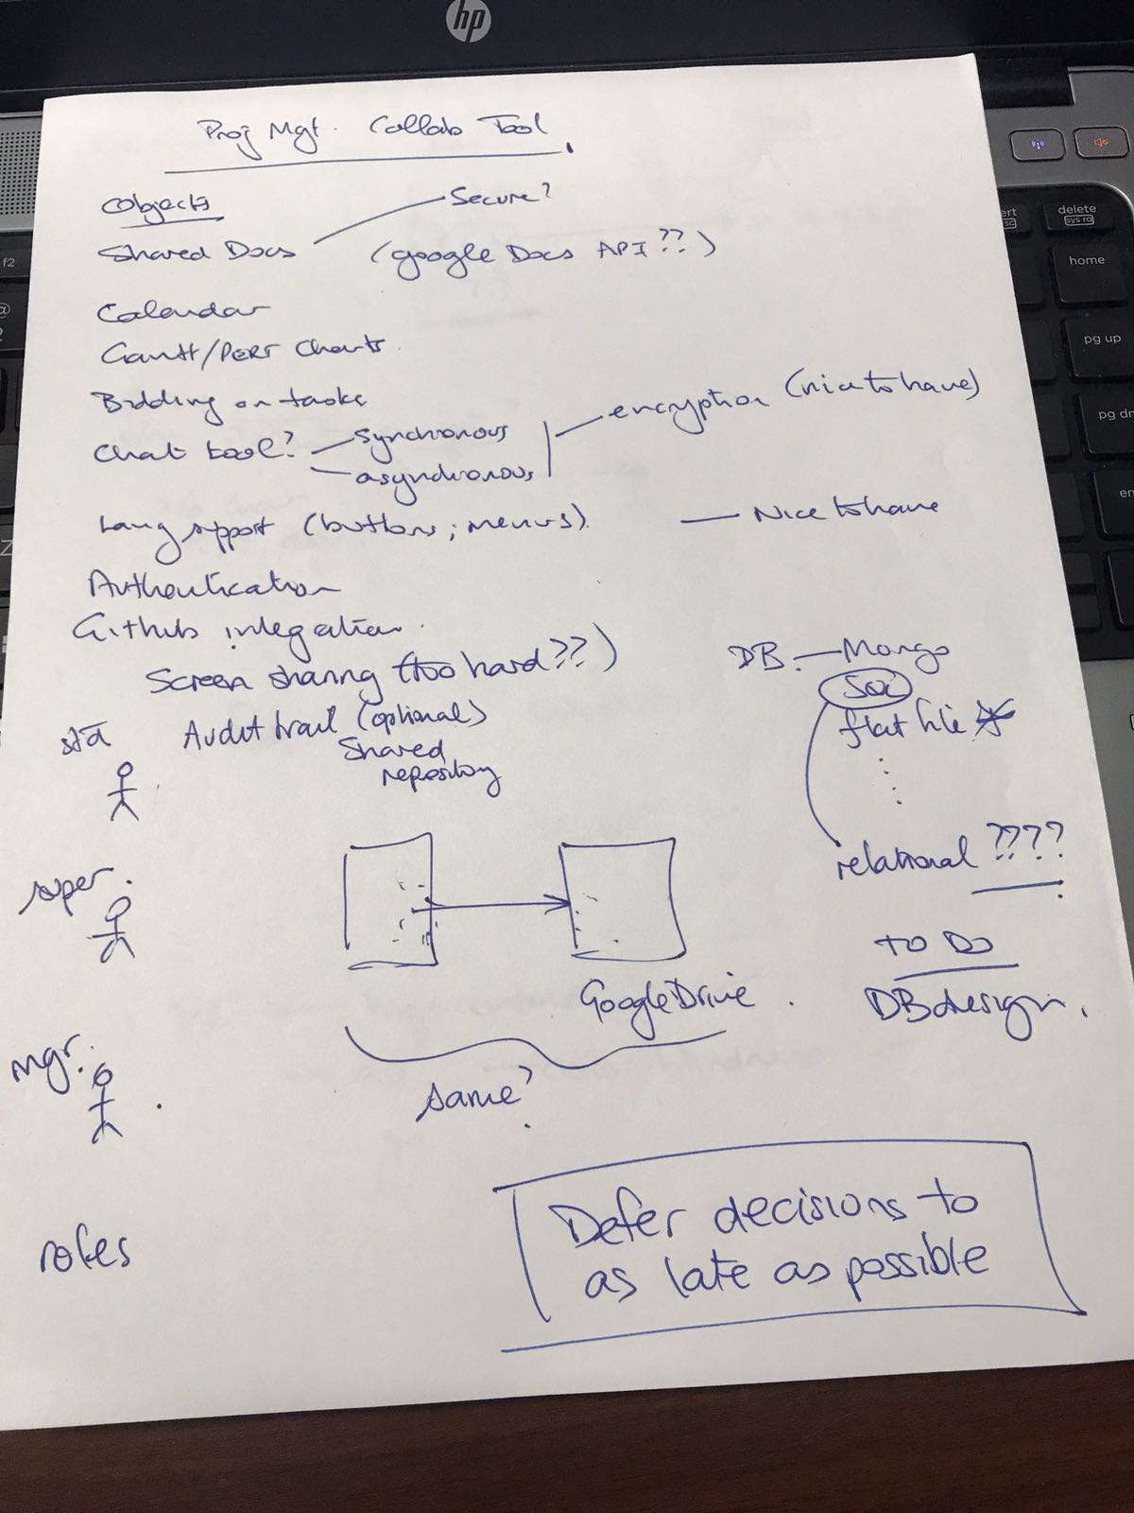

Figure 1 Client Requirements

I have researched about some collaboration tools to work for some use cases and prototype of the project. I have done use cases’ diagrams of shared document requirement and documented the test case plans for the shared document. I have spent over 38 hours outside this week.

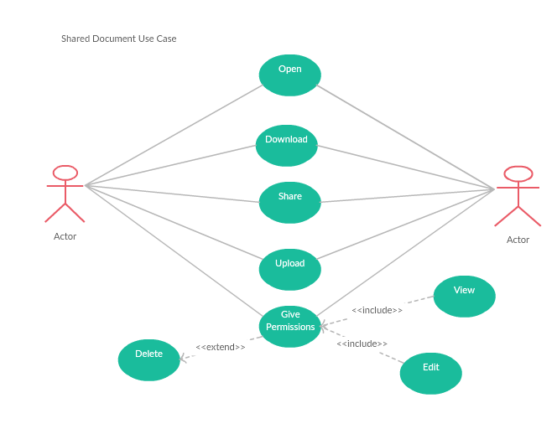

Figure-2 Shared Document Use Case

Planned work this week:

I am planning to work on some issues that are in the project and want to work more on prototype of the project and test cases. I want to spend some time researching on databases which works for our data management plan for the next week. I am planning to work for the mid-term presentation. I also want to research more on collaboration tools. I expect to spend 39 hours during the following week.